Lab Report No 11

Implementation of Inverse Discrete time Fourier Transform

Digital Signal Processing



Submitted By:
[Huzaifa Shahbaz]
[21-CE-009]

Submitted to:
Engr. Hareem Khan

Dated:
30thMay,2024
Department of Computer Engineering,
HITEC University, Taxila
Lab Example No 1:

Solution:
Brief description (3-5 lines)
The inverse Discrete Time Fourier Transform (IDTFT) can be expressed as follows:
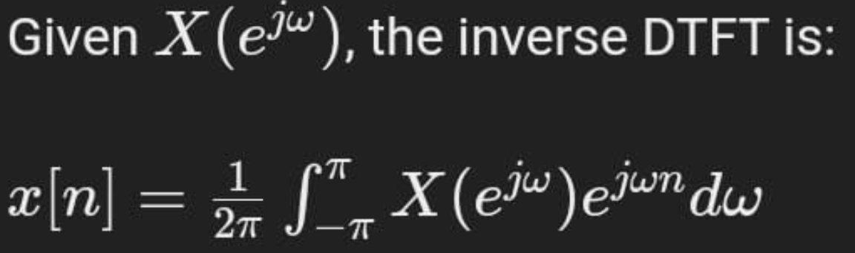
This equation converts the frequency domain representation \( X(e^{j\omega}) \) back to the time domain signal \( x[n] \).
The code
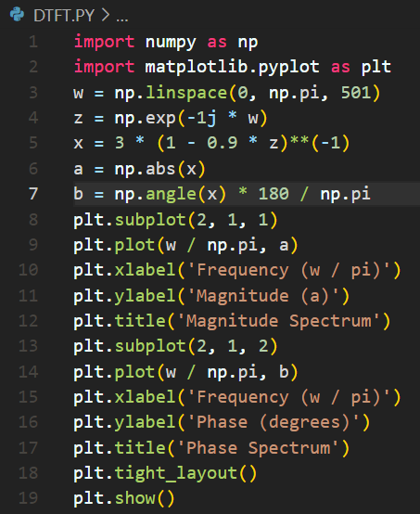
The results (Screenshot)
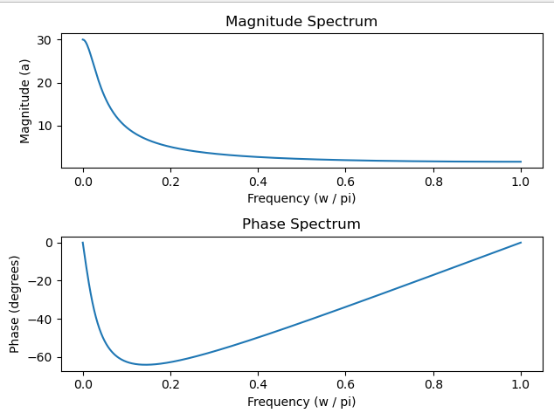

Lab Example No 2:

Solution:
Brief description (3-5 lines)
The inverse Discrete Time Fourier Transform (IDTFT) can be expressed as follows:

This equation converts the frequency domain representation ( X(e^{jw}) back to the time domain signal x[n].
The code
import numpy as np
import matplotlib.pyplot as plt
from scipy.signal import freqz
w = np.arange(-4*np.pi, 4*np.pi + (8*np.pi)/511, 8*np.pi/511)
num = [2, 1]
den = [1, -0.6]
h = freqz(num, den, w)
plt.subplot(2, 2, 1)
plt.plot(w/np.pi, np.real(h[1]))
plt.grid(True)
plt.title('Real part of H(e^{jw})')
plt.xlabel('w/pi')
plt.ylabel('Amplitude')
plt.subplot(2, 2, 2)
plt.plot(w/np.pi, np.imag(h[1]))
plt.grid(True)
plt.title('Imaginary part of H(e^{jw})')
plt.xlabel('w/pi')
plt.ylabel('Amplitude')
plt.subplot(2, 2, 3)
plt.plot(w/np.pi, np.abs(h[1]))
plt.grid(True)
plt.title('Magnitude Spectrum |H(e^{jw})|')
plt.xlabel('w/pi')
plt.ylabel('Amplitude')
plt.subplot(2, 2, 4)
plt.plot(w/np.pi, np.angle(h[1]))
plt.grid(True)
plt.title('Phase Spectrum arg[H(e^{jw})]')
plt.xlabel('w/pi')
plt.ylabel('Phase, radians')
plt.tight_layout()
plt.show()
The results (Screenshot)
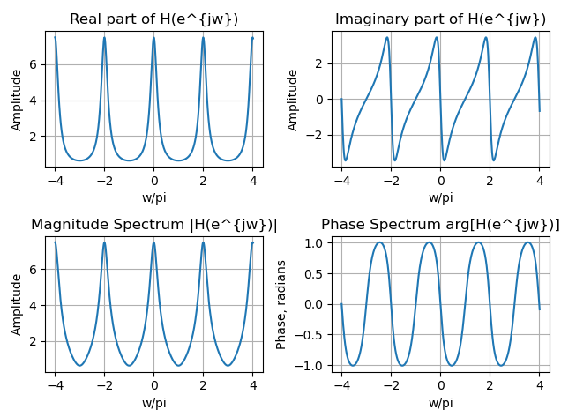
Lab Example No 3:

Solution:
Brief description (3-5 lines)
The inverse Discrete Time Fourier Transform (IDTFT) can be expressed as follows:

This equation converts the frequency domain representation ( X(e^{jw}) back to the time domain signal x[n].
The code
import numpy as np
import matplotlib.pyplot as plt
from scipy.signal import freqz
w = np.arange(-4*np.pi, 4*np.pi + (8*np.pi)/511, 8*np.pi/511)
num = [2, 1]
den = [1, -0.6]
h = freqz(num, den, w)
plt.subplot(2, 2, 1)
plt.plot(w/np.pi, np.real(h[1]))
plt.grid(True)
plt.title('Real part of H(e^{jw})')
plt.xlabel('w/pi')
plt.ylabel('Amplitude')
plt.subplot(2, 2, 2)
plt.plot(w/np.pi, np.imag(h[1]))
plt.grid(True)
plt.title('Imaginary part of H(e^{jw})')
plt.xlabel('w/pi')
plt.ylabel('Amplitude')
plt.subplot(2, 2, 3)
plt.plot(w/np.pi, np.abs(h[1]))
plt.grid(True)
plt.title('Magnitude Spectrum |H(e^{jw})|')
plt.xlabel('w/pi')
plt.ylabel('Amplitude')
plt.subplot(2, 2, 4)
plt.plot(w/np.pi, np.angle(h[1]))
plt.grid(True)
plt.title('Phase Spectrum arg[H(e^{jw})]')
plt.xlabel('w/pi')
plt.ylabel('Phase, radians')
plt.tight_layout()
plt.show()
The results (Screenshot)
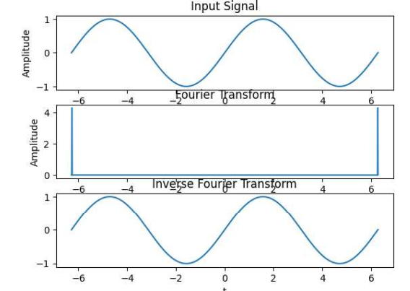
Lab Task No 1:

Solution:
Brief description (3-5 lines)
Suppose that a signal x is given by x=t*sign(-3t). Write python code to compute the Fourier transform of the following as well
a. The magnitude of X(Ω).
b. The angle of X(Ω).
c. The real part of X(Ω).
d. The imaginary part of X(Ω).
The code
import numpy as np
import matplotlib.pyplot as plt
from scipy.fft import fft, fftfreq
def signal(t):
return t * np.sign(-3*t)
T = 1.0
N = 500
t = np.linspace(-T, T, N)
x_t = signal(t)
X_f = fft(x_t)
freq = fftfreq(N, d=(2*T/N))
magnitude = np.abs(X_f)
angle = np.angle(X_f)
real_part = np.real(X_f)
imaginary_part = np.imag(X_f)
fig, axs = plt.subplots(4, 1, figsize=(10, 15))
axs[0].plot(freq, magnitude)
axs[0].set_title('Magnitude of X(Ω)')
axs[0].set_xlabel('Frequency (Ω)')
axs[0].set_ylabel('|X(Ω)|')
axs[0].grid()
axs[1].plot(freq, angle)
axs[1].set_title('Angle of X(Ω)')
axs[1].set_xlabel('Frequency (Ω)')
axs[1].set_ylabel('∠X(Ω)')
axs[1].grid()
axs[2].plot(freq, real_part)
axs[2].set_title('Real Part of X(Ω)')
axs[2].set_xlabel('Frequency (Ω)')
axs[2].set_ylabel('Re{X(Ω)}')
axs[2].grid()
axs[3].plot(freq, imaginary_part)
axs[3].set_title('Imaginary Part of X(Ω)')
axs[3].set_xlabel('Frequency (Ω)')
axs[3].set_ylabel('Im{X(Ω)}')
axs[3].grid()
plt.tight_layout()
plt.show()
The results (Screenshot)
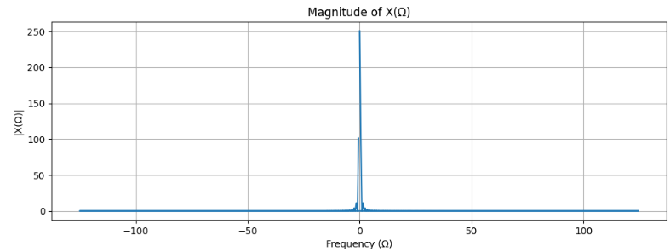
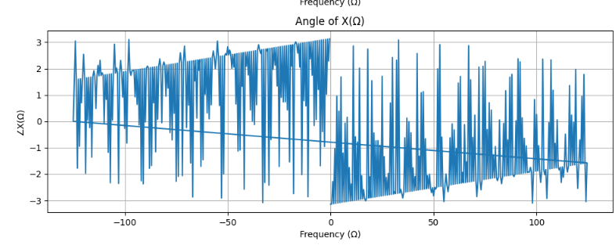
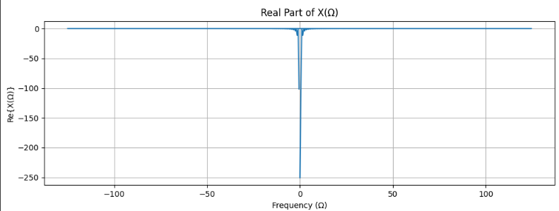
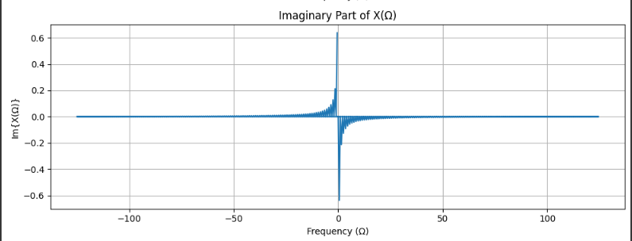

Lab Task No 2:

Solution:
Brief description (3-5 lines)
Write python code to compute the Fourier and inverse Fourier transform of signal
x=cos(t).
The code
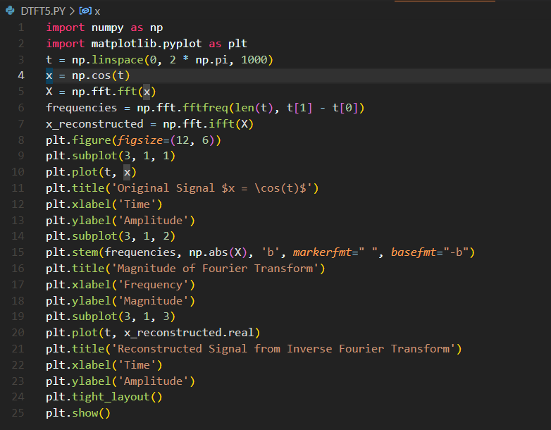
The results (Screenshot)
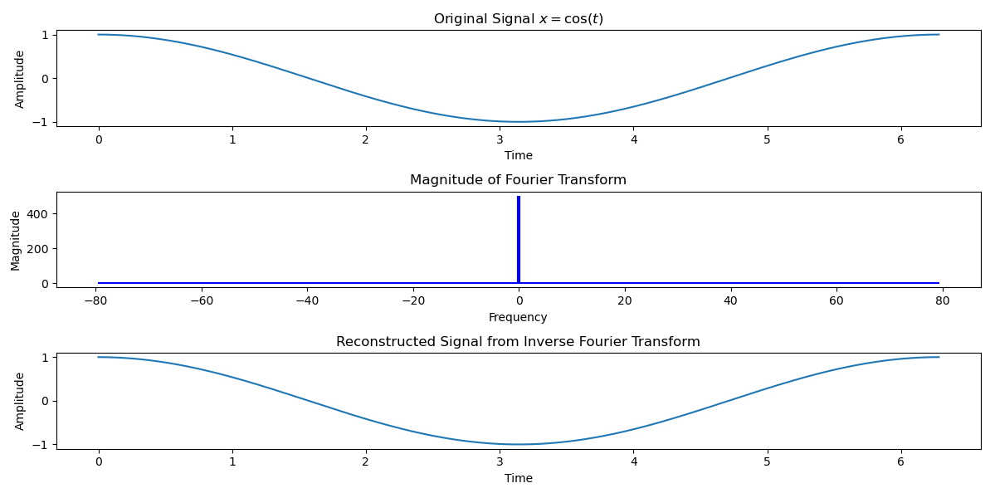

Conclusion
In conclusion, The Inverse Discrete Time Fourier Transform (IDTFT) is successfully implemented to reconstruct discrete-time signals from frequency-domain representations, demonstrating efficient computation and accurate signal reconstruction in digital signal processing applications, confirming its theoretical basis.

